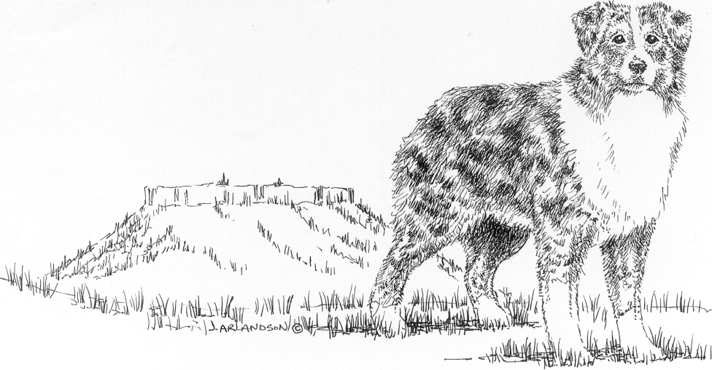
                                    

The Australian Shepherd Club of Rogue Valley, Inc.
Membership Application

Name(s): _____________________________________________________________

Address: _____________________________________________________________

City: _________________________________ State: ______ Zip: _____________

Phone: ( )_______________ E-mail:__________________________
Kennel name: _____________________________
Dog(s) names and breed: ________________________________________________
Please check your main interests relating to Australian Shepherds and / or this club:

Breeding and selling puppies Herding trials
Conformation showing Handling / Showmanship
Obedience/ Rally Junior programs
Agility Tracking, SAR
Helping at club functions Pets
Other:_________________________

Are you sponsored by a club member (not required)? If so, list member____________
What other dog related clubs are you a member of? ____________________________

Membership dues

Single membership $15.00 – includes one vote
Family membership $20.00 – includes two votes (includes juniors)
Junior membership $5.00 – no voting- not necessary if parents have a family membership
Dues are payable on or before January 1st of each year. Members in arrears 60 days shall be dropped from membership. Dues are pro-rated for new members after June 1st.
Applications for new memberships will be subject to approval at the next scheduled meeting.
_ _ _ _ _ _ _ _ _ _ _ _ _ _ _ _ _ _ _ _ _ _ _ _ _ _ _ _ _ _ _ _ _ _ _ _ _ _ _ _ _ _ _ _ _ _ _ _

I agree to abide by the Constitution, ByLaws, Registry rules, Code of Ethics and Dispute Resolution rules of both ASCA and the Australian Shepherd Club of Rogue Valley

Signed: __________________ Date:___________Amount enclosed: ______________

Checks to ASCRV and mail with this form to:

Dean Garrison 318 Rustic Canyon Drive, Grants Pass, OR 97526

New members only- date received___ date read at meeting ___ approved? ___

